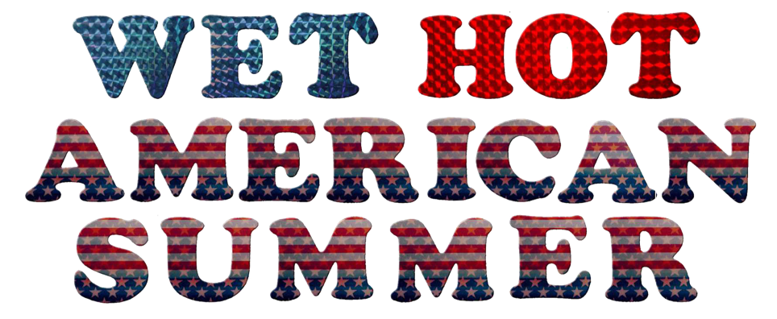

Creative Licensing Teams With Wet Hot American Summer

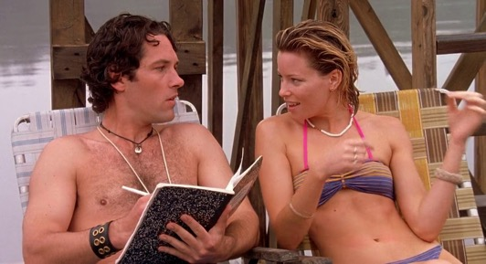
Los Angeles , CA - The creative team behind the 2001 cult classic, Wet Hot American Summer, has appointed Creative Licensing as the worldwide merchandise licensing agent for the film. The partnership will build off of Wet Hot’s current licensing program, with the goal of expanding into categories such as apparel, art posters, summertime accessories, board games, publishing, promotional tie-ins, specialty gifts and live action entertainment.

Creative Licensing’s director, Stephanie Marlis, remarks, “Wet Hot has amassed a huge cult following thanks to its iconic scenes, unforgettable oddball quotes, and star-studded cast, with names like Paul Rudd, Bradley Cooper, and Amy Poehler anchoring the film. We are looking forward to finding those partners who are devoted to producing fan-first products.”

Howard Bernstein, producer of Wet Hot American Summer, adds, “We look forward to collaborating with Creative Licensing to provide unique and creative products and opportunities for the fans, who have been so great in supporting Wet Hot for so many years.”

Current licensees include Mondo, Ripple Junction, and Rusted Wave, with apparel merchandise located at these retail outlets: Urban Outfitters, Kohl’s, Spencer’s, and Hot Topic.

