LICENSING WORKS!® SIGNS ROSTER OF NEW LICENSEES READY TO CELEBRATE
THE 75TH ANNIVERSARY OF THE LITTLE PRINCE™/LE PETIT PRINCE® IN 2018

Licensing Works!® signs a roster of new licensees in support of the 75th Anniversary of
The Little Prince™ / Le Petit Prince®, one the world’s best-loved books, first published in
New York in 1943. A host of new partners join offerings from long-time master publishing partner Houghton Mifflin Harcourt (HMH) to celebrate this milestone in 2018.

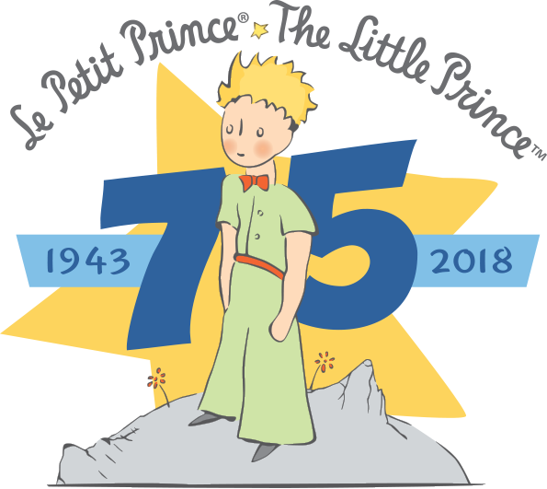
For the first time, The Little Prince will be featured on a full range of infant and toddler products. Finn and Emma is producing infant apparel, sleepwear, bibs, blankets, knit toys, rattles, swaddles sold in gift sets, teethers, stroller accessories, play mats and play gyms available beginning October ‘17. Little Unicorn is featuring The Little Prince on hooded towels and washcloth sets, fitted sheets, quilts, changing pad covers and swaddles sold alone or in multi-packs available Spring ‘18. Storiarts is offering key editorial and graphics on their unique infant caps and baby blankets.

The 75th is supported with an Anniversary calendar from Rizzoli’s Universe imprint, now available for pre-orders on-line and soon in stores. Out of Print is in market with bags, tops, unisex socks, onesies, pins and cases including a Nook exclusive case which will be available only at Barnes & Noble. Culturenik is offering bookmarks, boxed gift mugs, canvas prints and small format prints. Vinca is selling beautifully designed earrings and necklaces. Riley Blake will be releasing fabric, notions and a fabric storybook that the consumer can custom make for unique gifts. Litographs is offering their unique T-shirts, scarves, posters and bags that each feature the completed story within the design. Socksmith is showcasing a line of men’s and women’s socks. G. Arts has created a beautiful range of laser cut wood products including lights, clocks, framed prints and magnets. Walls360 continues to offer a full range of lift-and-place wall graphics.

Sofitel Luxury Hotels continues a five-year relationship with Le Petit Prince which will include the 75th Anniversary in 2018. Working together, in support of the Antoine de Saint-Exupéry Foundation for Youth (FASEJ), consumers can enjoy special offers through “Magnifique Family” translated throughout the Sofitel system with special programs targeted to young travelers and their families.

The Little Prince/Le Petit Prince is a worldwide publishing phenomenon. With 300 official translations, The Little Prince is the Most Translated Book in the World, after the Bible. It is also among the best-selling books for youth worldwide. There have been over 200 million copies in print with over 500 million readers globally. The book continues to sell 2 million copies annually, with 300,000 being sold in English in the U.S. each year.

Saint-Exupéry wrote this as a children’s book intended for grown-ups but it can be read on many different levels to provide pleasure and food for thought for readers of all ages. The Little Prince is inspired in part by Saint-Exupéry's own experiences as a pilot marooned in the Sahara Desert during a long-distance race and speaks to the global values of humanity, concern for the environment, the specialness of childhood, love and friendship.

With a 90% awareness, the property has more than 200 active licensees worldwide generating over 10,000 different products. With over 10 million Facebook fans and over 3.2 million views on YouTube, the on-line presence is strong, including an official website in six languages with a half a million unique visitors annually. Online store research profiles a core target of young mothers in their 30’s, well-educated who want to share the values communicated in The Little Prince book. 70% of the online consumers are Women 25-49. The recent release of the $70 million dollar stop-motion animated feature film includes all-star voice cast and an Oscar nominated director, and has been seen by over 23 million in theaters with an additional
30 million+ on Netflix.

Licensing rights in the U.S. are available for Apparel and Accessories, Toys, Games, Interactive, Stationery, Gift, Consumables, Domestics and Home Décor and all other relevant categories. Licenses granted will include use of the 75th Anniversary logo for all product celebrating this 2018 anniversary.

###

Contact: Leslie Levine, Licensing Works!®, 702-485-5677, leslie@licensingworks.us
About Licensing Works: Licensing Works!® represents the creators and owners of intellectual property for merchandise licensing and promotions including: Zorro®, the Edgar Rice Burroughs portfolio (including Tarzan®), Puppy In My Pocket®, Kewpie®, Moulin Rouge®, Mundo Lanugo®, The Little Prince™/Le Petit Prince®, Robot Farm™, Intellivision® and Molang.
About The Estate of Antoine de Saint-Exupéry: A French company officially known as Société pour la Gestion et l’Exploitation des Droits Dérivés de l’Oeuvre d’Antoine de Saint-Exupéry or as abbreviated, SOGEX. SOGEX is the Global Licensor who owns and controls all rights in and relating to The Little Prince™/Le Petit Prince®.

