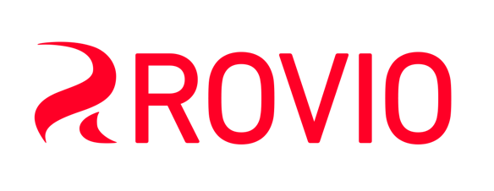
Rovio Entertainment Ltd. – Company Presentation
Rovio Entertainment Ltd., based in Espoo, Finland, is the creator of Angry Birds, the casual mobile game that changed an industry and became an international phenomenon. Today Angry Birds is not only the most downloaded series of games of all time, it is a renowned entertainment brand that has branched out into animation, licensing and more. The Angry Birds Movie was released in May 2016.
Two business areas: Games and Brand Licensing
Rovio Entertainment crates world-class entertainment experiences with its two business units: Games and Brand Licensing.
Games unit focuses on Free-to-Play (F2P) mobile games with mission to set the world on fire again by enabling teams to craft the best mobile games. Our games portfolio consists of both Angry Birds and other IP games. Currently we have two Top 40 grossing games in the US iPhone chart: Angry Birds 2 and Angry Birds Blast. Our other key games include Angry Birds Friends and Angry Birds Pop. We also have several exciting new games in production including our first real-time, player-vs-player multiplayer game Battle Bay in soft launch. We have game studios in Espoo, Stockholm and London.
Brand Licensing unit focuses on non-games areas to create other forms of entertainment experiences including consumer products, feature films, animated series, location based entertainment and books & comics. Our world-class partners include Sony Pictures, LEGO and H&M. The highlight so far has been the global release of The Angry Birds Movie in 2016 hitting nearly $350 million at the worldwide box office. We are planning the sequel to The Angry Birds Movie.
Strong financial performance in 2016
Rovio Entertainment Oy returned to profitable growth after a highly successful 2016, which saw a record performance in the company’s Games unit and a blockbuster release of The Angry Birds Movie. Gross revenue of Rovio grew by 35% to €191.7M (€142.1M in 2015). Earnings Before Interests and Taxes (EBIT) improved to €16.9M (-€21,1M in 2015).
Games unit achieved a record-high revenue while improving its profitability significantly. Gross revenue was €159.0M (€113.5M in 2015) and EBIT €29.5M (€4.0M in 2015) giving a profit margin (EBIT margin) of 19%. The strong growth was based on extended life cycles and improved performance metrics of Rovio’s key games. Rovio’s best performing games in 2016 included Angry Birds 2, Angry Birds Friends and Angry Birds POP, all with increased revenues year on year.
Brand Licensing unit increased its revenue and improved profitability in 2016. The gross revenue of Brand Licensing unit was €32.7M (€28,6M in 2015). EBIT was -€1,0M (-€13,1M in 2015) due to most of the revenue related to the movie will be recognized in 2017 and 2018. . The highlight of Brand Licensing unit in 2016 was the global release of The Angry Birds Movie hitting nearly $350 million at the worldwide box office. The Angry Birds Movie opened number one in 52 countries and was the third largest foreign animated movie in China ever.
Outlook for 2017
In 2017 Rovio Entertainment will continue to invest in development and performance marketing of games. With a strong fan engagement, uplift in the Angry Birds brand, brand licensing activities, and revenues from The Angry Birds Movie, the company sees opportunities to further improve profitability while staying on its growth track.

