SONY PICTURES ENTERTAINMENT 2018
HOTEL TRANSYLVANIA 3: SUMMER VACATION | JULY 13, 2018
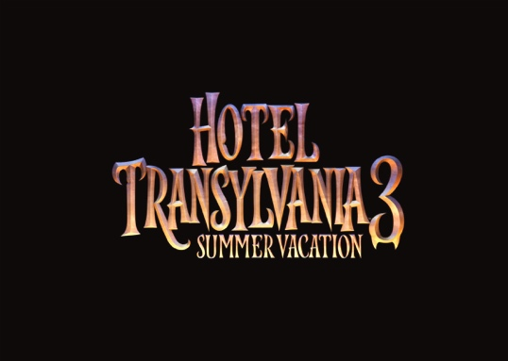
In Sony Pictures Animation’s Hotel Transylvania 3: Summer Vacation, join our favorite monster family as they embark on a vacation on a luxury monster cruise ship so Drac can take a summer vacation from providing everyone else’s vacation at the hotel. It’s smooth sailing for Drac’s Pack as the monsters indulge in all of the shipboard fun the cruise has to offer, from monster volleyball to exotic excursions, and catching up on their moon tans. But the dream vacation turns into a nightmare when Mavis realizes Drac has fallen for the mysterious captain of the ship, Ericka, who hides a dangerous secret that could destroy all of monsterkind.
Just in time for the film, fans can stock up on Hotel Transylvania’s biggest consumer products program ever that includes toys, apparel, location based entertainment, publishing, games and more!
Licensees: Jazwares, Simon & Schuster Children’s Books, Papercutz, Bendon, Inc. and more.
HOTEL TRANSYLVANIA: THE SERIES
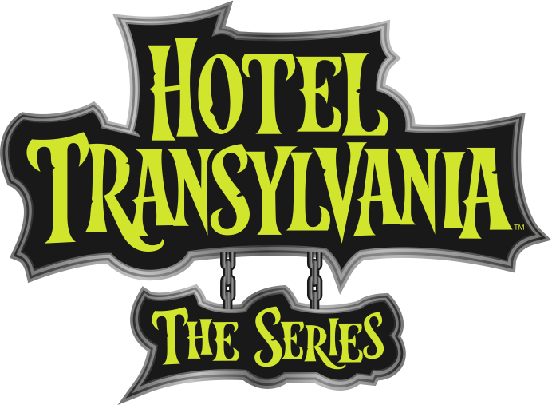
Based on the popular Hotel Transylvania film franchise, Corus Entertainment’s Nelvana and Sony Pictures Animation’s all new hit television series Hotel Transylvania: The Series continues to perform across key demographics on Disney Channel. The series focuses on the [mis]adventures of Dracula's teenage daughter Mavis and her three closest friends Hank N Stein, Pedro and Wendy Blob.
Hotel Transylvania: The Series is currently available on Disney Channel worldwide and on Super RTL in Germany. The series will premiere its first season on Netflix in the U.S. starting Summer 2018 and will continue to roll out throughout the world starting Fall 2018.

JUMANJI: WELCOME TO THE JUNGLE
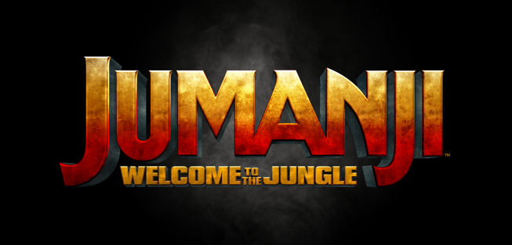
The latest film in the franchise, Jumanji: Welcome to the Jungle, takes the action, thrills and adventure to a whole new level since the premiere of the original Jumanji film more than 20 years ago.
Jumanji: Welcome to the Jungle has reinvigorated the franchise, catapulting the film to global box office records as it nears the impressive $1billion benchmark. With a strong line-up of licensees and impressive results at retail, fans worldwide are eager for more films and merchandise. Stay tuned for more exciting Jumanji news…
Licensees: Cardinal Industries, Funko, LLC, Isaac Morris Limited, Escape Key Entertainment and more.

MEN IN BLACK (UNTITLED) | June 14, 2019
For 20 years, this iconic $1.6 billion global franchise continues to resonate in pop-culture with theme park attractions, television series, digital gaming and more. Get ready! An all-new M.I.B. spinoff from the original film is on the way! Look for more exciting announcements coming soon!
Licensees: TBA

GHOSTBUSTERS 35TH ANNIVERSARY | Summer 2019
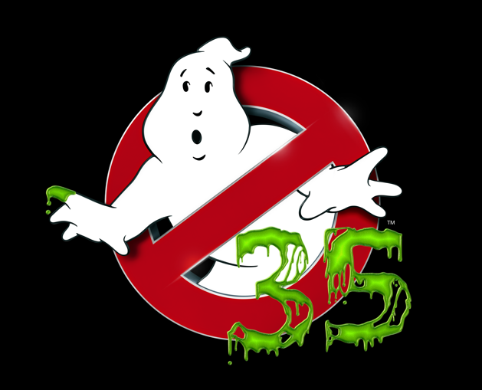
Ghostbusters is an iconic brand with near universal awareness. Its rich legacy continues to appeal to audiences generation after generation. For Ghostbusters 35th Anniversary, Sony Pictures Entertainment is producing a jam-packed year of activations, partnerships and incredible exclusives lined up in celebration of the 1984 classic film.
Look for more exciting news coming soon on Ghostbusters Day - June 8th!
Licensees: Playmobil, Funko, Inc., Mattel, Inc., Simon & Schuster Children’s Book, Idea and Design Works, LLC, Publishing, Diamond Select Toys and Collectibles, LLC, Hybrid Promotions, LLC, New Era Cap Co, Inc., The Void, LLC, and more.

SONY PICTURES ENTERTAINMENT CLASSSIC FILMS
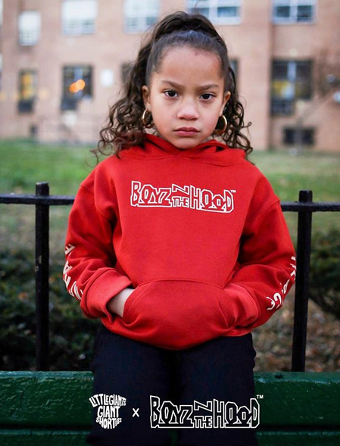
Sony Pictures Entertainment classic films can enhance and complement pop-cultural trends that are ripe for added value across categories such as apparel, interactive games, accessories, collectibles and more.
Some upcoming opportunities include The Karate Kid 35th Anniversary, Superbad, Step Brothers 10th Anniversary, Poetic Justice 25th Anniversary, and Easy Rider 50th Anniversary.
Licensees: Ripple Junction Design Co. Inc,, The Hundreds, Stance Socks, Little Giants, New Moda, and more.

A DOG’S WAY HOME
For centuries people have enjoyed a unique unbreakable bond with their pets. A Dog’s Way Home is an emotionally charged story that highlights the power of the unconditional love between a dog and their human and celebrates the lengths that one dog will go to reunite with their human. A Dog’s Way Home is directed by Charles Martin Smith from the script by W. Bruce Cameron and wife Cathryn Michon, based on Cameron’s best-selling book.
Licenses: TBA
GOOSEBUMPS: HAUNTED HALLOWEEN | OCTOBER 12, 2018
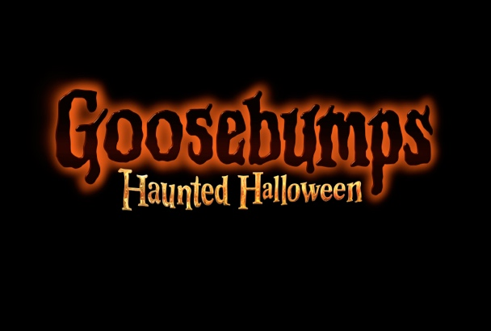
Following the success of the first film, Sony Pictures Entertainment is representing merchandising rights for the classic book property and the film franchise.
Join Slappy and his "friends" on their next adventure in Goosebumps: Haunted Halloween! Based on the worldwide best-selling literary franchise by R.L. Stine, Goosebumps is back with director Ari Sandel (Monster High, The Duff), returning fan favorite Slappy, and new characters played by Madison Iseman (Jumanji: Welcome to the Jungle), Caleel Harris (Think Like A Man), and Jeremy Ray Taylor (It).
Goosebumps: Haunted Halloween is the perfect Halloween movie that delivers fresh, fun thrills for the whole family and ghoulish products from a new and returning roster of licensees!
Licensees: TBA

